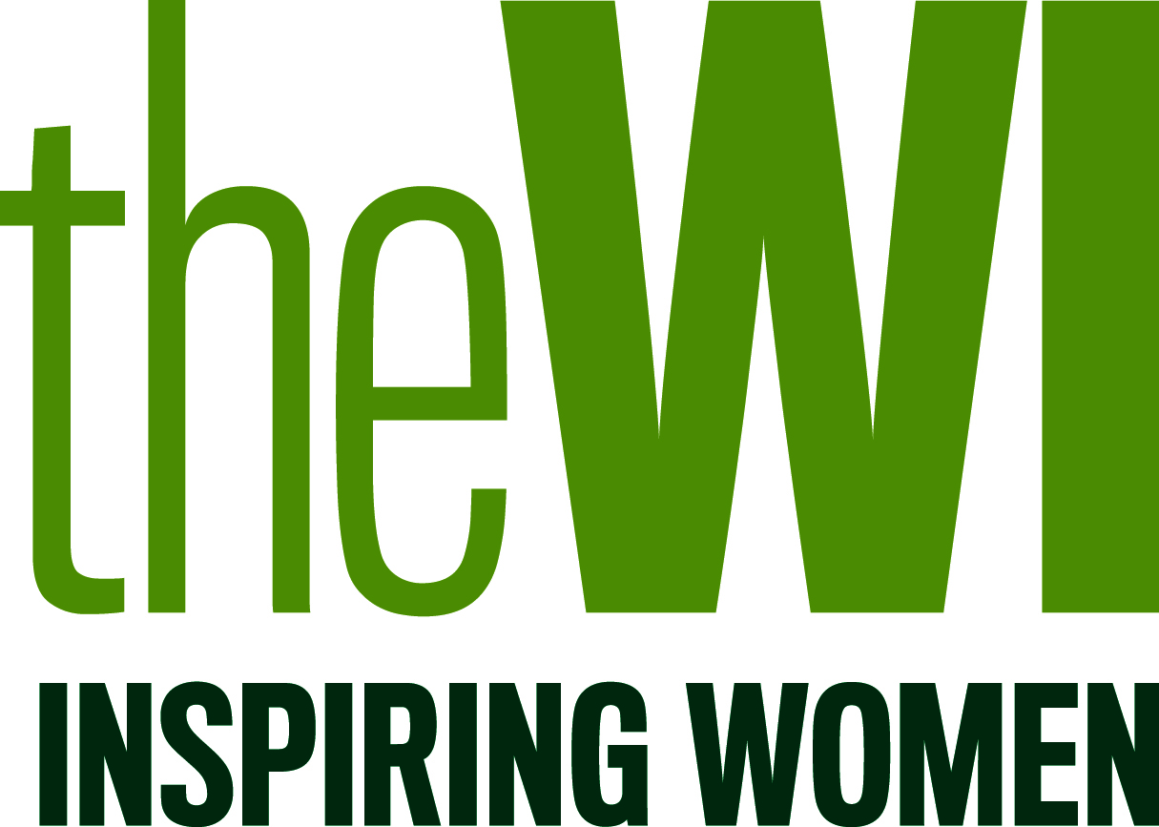 STARTING A NEW WI
To start a new WI the following must be in place:
- At least 12 – 15 very interested people
- Somewhere to meet on a regular monthly basis
- A time to meet
- Publicity for the Introductory Meeting
- Someone to be the main point of contact
- It is essential to contact the Federation secretary@nottswi.org.uk for a WI Adviser to be booked to lead the meeting.
It would be helpful if:
There were at least 3 people within this group who would be on a committee
Other WIs in the area have been checked out or visited.
The group has ideas (plus any contacts) for the first 3 to 6 meetings
The County Federation covers the cost of:
The WI Advisers’ and WI Supporters’ travel expenses.
The first 3 meetings of a proposed WI – introductory, first, then formation; but it is good for the WI if attendees pay for their tea and a raffle ticket – usually 50p each. A new WI has a budget of £350 for these three exploratory meetings [plus stationary]. The budget must cover all expenses including rent for hall, activities, speakers, items for refreshments etc. An invoice or receipt must be presented to County Office for payment.
The new members have to decide:
- The name of their WI
- When and where they will meet
- The number on the committee
- The number of Vice-presidents
- The month of their Annual Meeting
- Where to open a bank account.
(The Federation looks after all monies including subscriptions, until the new WI has a bank account. Cheques for subscriptions should be payable to Notts Federation of WIs) OR members may pay by
BACS: NOTTS FED WI REDG CHARITY. SORT CODE: 05 06 22 ACCOUNT NO: 50342581 Ref. the name of the new WI
Financing a new WI
Once a bank account is opened a new WI keeps all the money raised, including subscriptions, during the actual year they are formed e.g. up to March 2022 for the running of their WI. At the start of the new year, e.g. April 2022, [and subsequent years when subs are due] then half of the subscription, plus other costs, go to the Federation and National.
A new WI is supported by members of the WI Support Team who will attend committee meetings and most monthly meetings for at least a year.

