CREATIVE ACTIVITIES |  |  | 
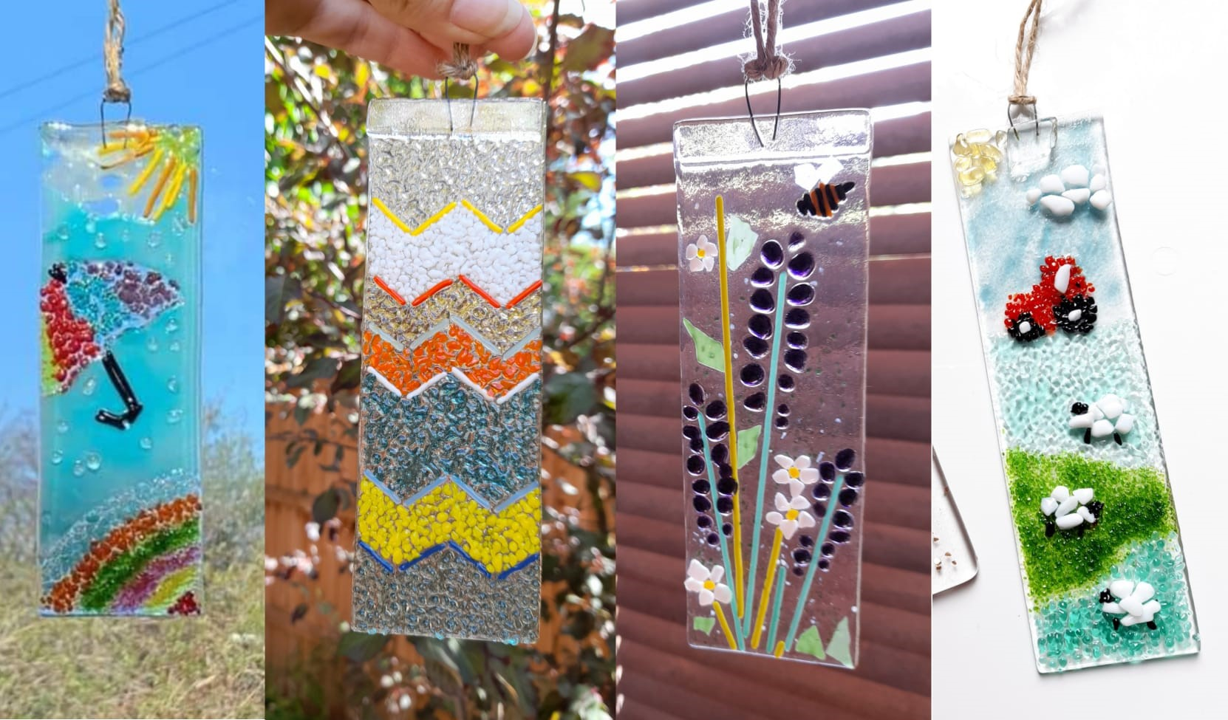 | 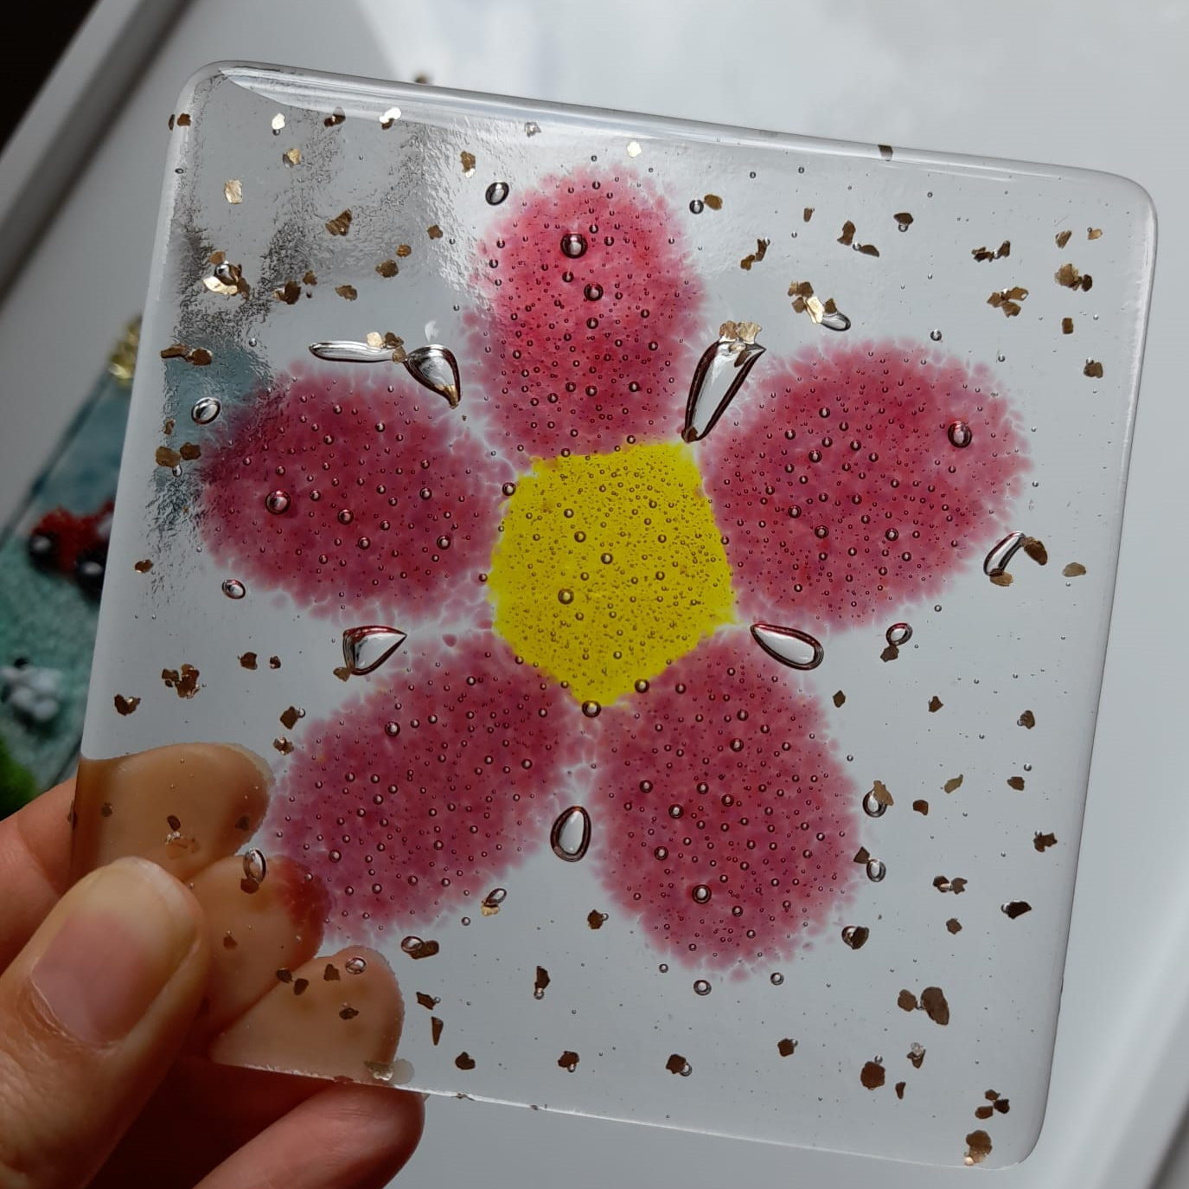 | GLASS FUSION  Date: Wednesday 15 January 2025  Time: Arrive 9.30am to start at 10am–1pm  Venue: Trent Bridge House, Beastmarket Hill, Newark, Notts, NG24 1BN  Price: £25 including all materials  Closing Date: Tuesday 17 December 2024  Online Booking & Payment link:  https://www.trybooking.com/uk/EBCI

At this session, you will be able to design and create your own unique lightcatcher or coaster. However, if you attended the last session, you will cut a pattern from fibre paper to form a base relief for the glass to be slumped into. You will add different types of coloured accessory glass to clear glass form your unique item. Once decorated, the tutor will take the pieces to be fired in her studio to be returned at a later date for you to collect. Please specify below, the project you would like to make.

Please complete the application form below and send to Notts Fed of WIs, Trent Bridge House, Beastmarket Hill, Newark, Notts, NG24 1BN along with a cheque made payable to Notts Fed of WIs (2 signatures on WI cheques please). All proceeds raised by this event will go into Federation funds. If, a week before the event, you have not received any tickets or notification that the event has been cancelled, please contact the office.

Glass Fusion – 15 January 2025
WI |  |  |  | Contact Name
Tel No |  |  | Email
Address (only if tickets are to be posted out):
Lightcatcher: _____ place(s) @ £23/person
Coaster: _____ place(s) @ £23/person
Pattern Cutting (only for those who attended a previous session) _____ place(s) @ £23/person

Total payment of £_____. Please tick payment method (see below) for further information.
Cash or card (in person in the office)
Cheque
BACS using ref ‘CA001’ was sent on ______________

Booking and Payment Options:
Online | Use the link at the top of the page to book and pay online. A transaction fee will be charged.
By Post  (BACS payment) | Apply using this form and send it to the address above. Send payment to Virgin Money Sort Code: 05 06 22; Account No: 50342581; Account Name: Notts Fed WI Regd Charity. Ref: use reference above and state when the BACS payment was sent.
By Post  (Cheque payment) | - Apply using this form and send to the address above with your cheque.  - Confirmation will be sent by email OR insert your postal address include £1 p&p.
In person in the office | Use this form, attend the office, and pay by cash, cheque or card.

