BOARD OF TRUSTEES |  | 
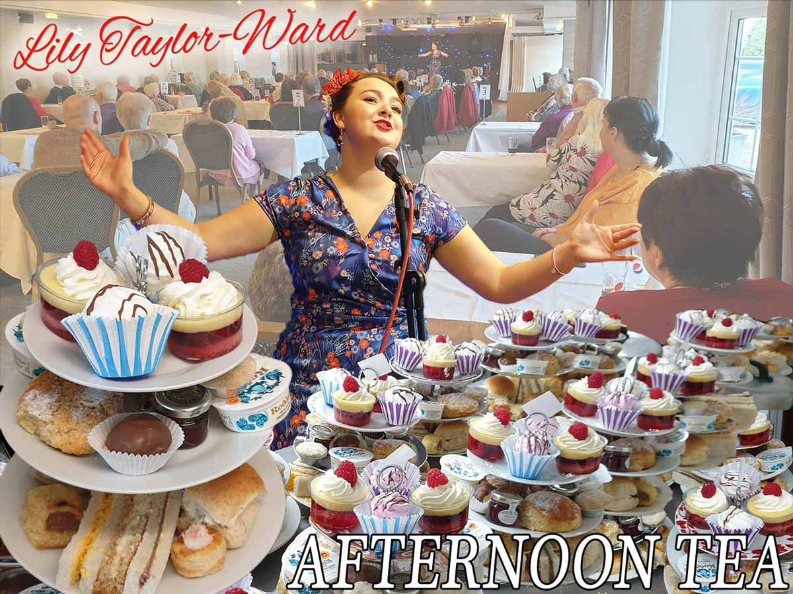 | AUTUMN AFTERNOON TEA  Date: Wednesday 8 October 2025  Time: 12.30 for 1pm (approx finish 3.30pm)  Venue: The Hostess Restaurant, Sookholme Rd,  Mansfield NG19 8LL  Price: £24.00 per person  Closing Date: Monday 15 September 2025  Online Booking: https://www.trybooking.com/uk/FALY

Enjoy a delicious selection of sandwiches, cakes and tea-time treats before listening to acclaimed classical soprano, Lily Taylor-Ward singing a selection of songs from her broad repertoire. She trained at the London College of Music and has subsequently played lead roles in numerous shows including West Side Story, Oliver! and Phantom of the Opera. Please let us know if you have any song requests to pass on to Lily.

Please complete the application form below and send to Notts Fed of WIs, Trent Bridge House, Beastmarket Hill, Newark, Notts, NG24 1BN along with a cheque made payable to Notts Fed of WIs (2 signatures on WI cheques please). All proceeds raised by this event will go into Federation funds. If, a week before the event, you have not received any tickets or notification that the event has been cancelled, please contact the office.

Autumn Afternoon Tea – 8 October 2025
WI |  |  |  | Contact Name
Tel No |  |  | Email
I require _____ ticket(s) at £24 per person. Total payment of £_____. Please tick payment method (see below) for further information).  Cash or card (in person in the office)  Cheque  BACS using ref ‘BT019’ was sent on _________  Any dietary requirements: |  |  |  |  |  | Or use this QR code to book online:  

Booking and Payment Options:
Online | Use the link at the top of the page or the QR code to book/pay online. A transaction fee will be charged.
By Post  (BACS payment) | Apply using this form and send it to the address above. Send payment to Virgin Money Sort Code: 05 06 22; Account No: 50342581; Account Name: Notts Fed WI Regd Charity. Ref: use reference above and state when the BACS payment was sent.
By Post  (Cheque payment) | - Apply using this form and send to the address above with your cheque.  - Confirmation will be sent by email OR insert your postal address include £1.50 p&p.
In person in the office | Use this form, attend the office, and pay by cash, cheque or card.

