NOTTINGHAMSHIRE FEDERATION BOARD of TRUSTEES

Compass Walks

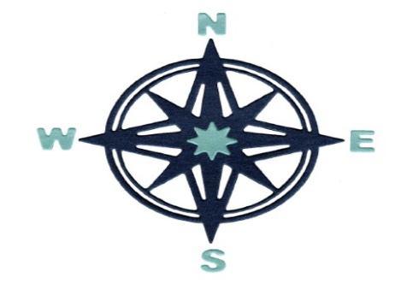

We have 5 walks for you to choose from: North, South, East, West, and one in the middle.
North: around Gringley on the Hill
South: around Car Colston
East: around Hoveringham & Bleasby
West: in the Kimberley area
Centre: in the middle around Eakring

To participate in the Compass Walks, by yourself or with a few friends, you need to obtain the route for the walk of your choice by emailing secretary@nottswi.org.uk or telephoning the office 01636 673550. All the options are available on Notts WI SharePoint in the WI Information folder.
When you have completed the walk, get in touch with the office and tell them the answer to the question associated with that particular walk.
Every group that completes a walk will receive an e-certificate. Any group that completes all FIVE walks will be entitled to an even better certificate! Why not set yourself the challenge to complete them all? The walks are undertaken at your own risk, and social distancing guidelines should be observed.
All walks are to be completed by 14 January 2021 in commemoration of the death of Edmond Halley, the inventor of the first modern compass.

