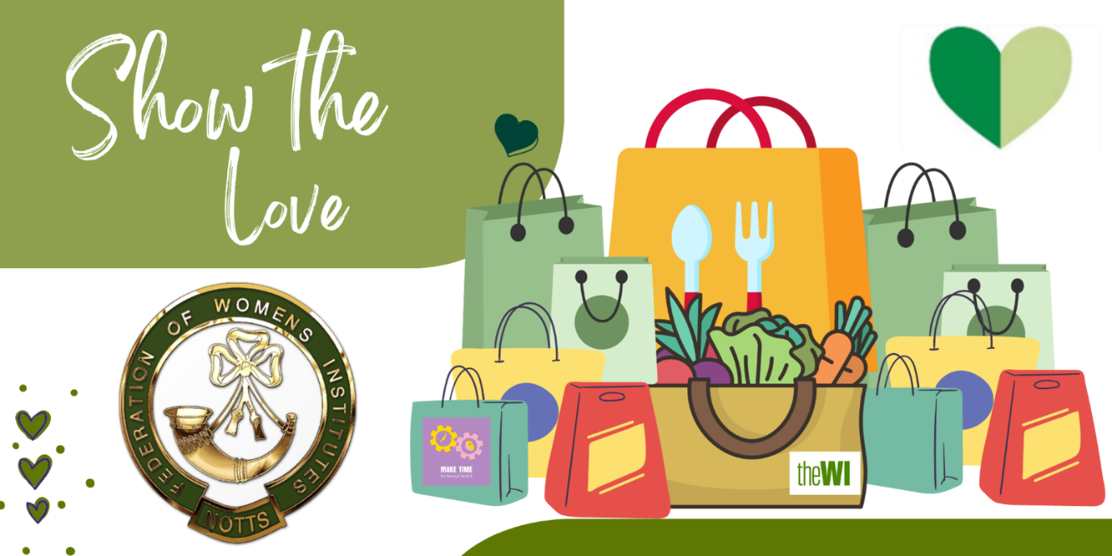
Bag Making Challenge

In February, the WI links up with the Climate Coalition to highlight “Show the Love” (also known as the Green Hearts campaign) which focuses on climate change. We want to challenge WI members to make bags for their local food banks; please check with your local branch to see if they would like to receive crafted bags as we would like to add them to our list.
We are asking you to make shopping bags (which could be made from reused material) to be given to food banks in your local area. We challenge you to see how many can be made in 6 months from February to September. This would hopefully help on reducing plastic waste. We would also encourage members to include food donations when dropping them off to their local food bank. Please submit your totals on this link https://forms.office.com/e/qPBjniJsJW or by email to suzanneplamping@nottswi.org.uk

The bag should be 45cm x 45cm (18"x18") minimum. There are lots of patterns available and we have added some to SharePoint (WI Information > Campaigns & Resolutions)

We will also be collecting them at our County Office, if your local foodbank does not want to take them, we have been in contact with several of the larger organisations across the county who will gratefully receive them.

Let's see who can make the most and see which WI gets the prize! Log your number of bags as you go along; these will be added together over the 6 months.

