CREATIVE ACTIVITIES
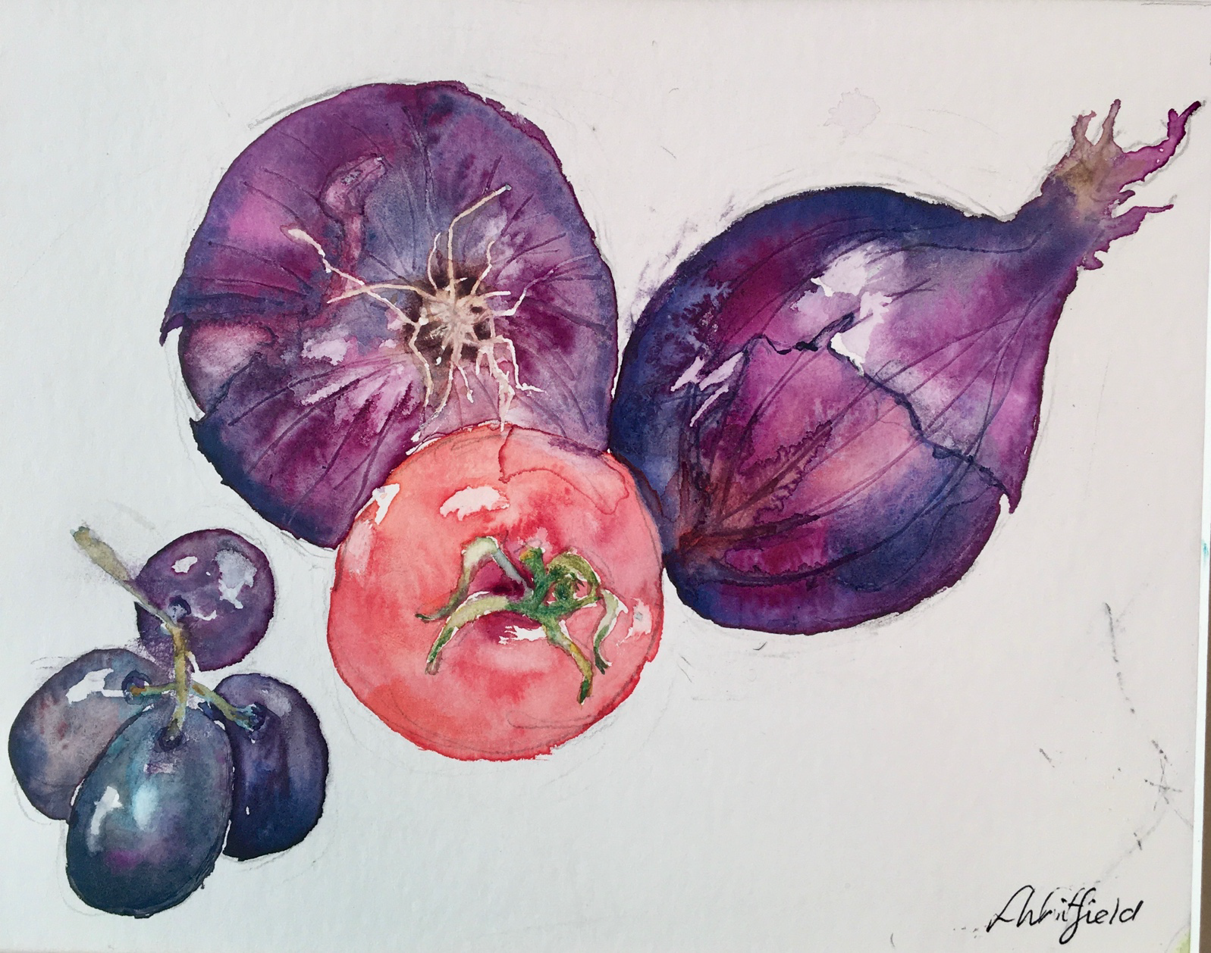 | WATERCOLOUR FOR BEGINNERS  Date: Thursday 16 May 2024  Time: Arrive 9.30am to start at 10am–4pm  Venue: Trent Bridge House, Beastmarket Hill, Newark, Notts, NG24 1BN  Price: £24 including all materials  Closing Date: Wednesday 24 April 2024

Local artist, Lynne Whitfield, will lead the group step by step, to show the beginner how to draw and paint a still life of fruit and vegetables using water colours. All materials will be supplied by the tutor so you don’t have to bring anything with you other than your lunch and enthusiasm! If you have your own paints and prefer to use them, feel free to bring them along. Hot drinks will be provided but please bring your lunch.

Please complete the application form below and send to Notts Fed of WIs, Trent Bridge House, Beastmarket Hill, Newark, Notts, NG24 1BN along with a cheque made payable to Notts Fed of WIs (2 signatures on WI cheques please). All proceeds raised by this event will go into Federation funds. If, a week before the event, you have not received any tickets or notification that the event has been cancelled, please contact the office.

Watercolour for Beginners – 16 May 2024
WI |  |  |  | Contact Name
Tel No |  |  | Email
Address (only if tickets are to be posted out):
_____ ticket(s) required at £24 per person. Total payment of £_____. Please tick payment method (see below) for further information).
Cash or card (in person in the office)
Cheque
BACS using ref ‘CA006’ was sent on ______________

Booking and Payment Options:
By Post  (BACS payment) | - Apply using this form and send to the address above.  - Our Bank details are:  Virgin Money (previously Yorkshire Bank/Clydesdale Bank)  Sort Code: 05 06 22; Account No: 50342581; Account Name: Notts Fed WI Regd Charity  Ref: use reference given form and state when the BACS payment was sent.
By Post  (Cheque payment) | - Apply using this form and send to the address above, along with your cheque made payable to Notts Fed of WIs.  - Please insert your email address as tickets will be sent this way unless you complete the postal address section (please include 75p p&p).
In person in the office (cash/cheque/card) | Apply using this form, attend in person in the office, and pay cash for which a receipt will be given, by cheque or card.

