|  |  |
| --- | --- |
|  |  |
| **CANADA CUP COMPETITION 2025** |

**For this competition we would like you to write an amusing caption for this photo, taken at a recent axe throwing event.**

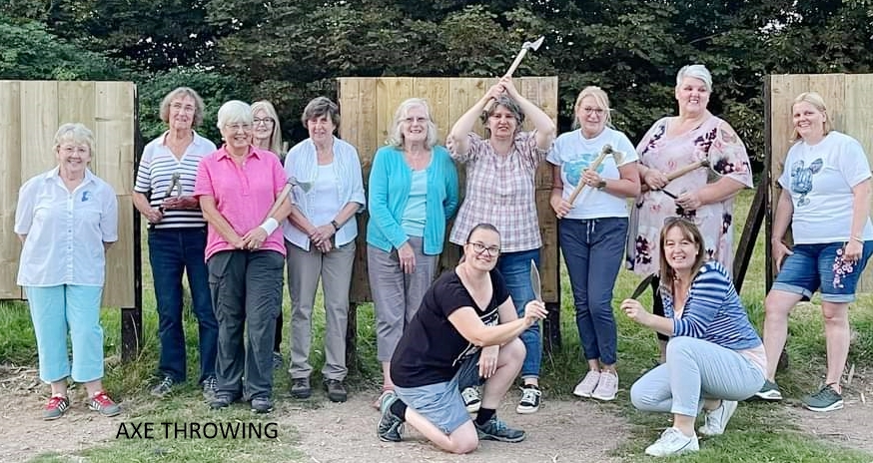

The **Canada Cup** was donated to the Federation byformer Federation Chairman, Pat Lambert’s sister. To celebrate the Federation’s Diamond Jubilee in 1977, a whole week of events took place at the Palace Theatre in Newark. She was so impressed with the celebrations, she donated to the Federation a Cup to be presented each year. The theme of each competition: it must be amusing!

**Please submit your entries to the office by**

**Friday 21 February 2025**

PTO

|  |  |
| --- | --- |
|  |  |
| **CANADA CUP COMPETITION 2025** |

**For this competition we would like you to write an amusing caption for this photo, taken at a recent axe throwing event.**

The **Canada Cup** was donated to the Federation byformer Federation Chairman, Pat Lambert’s sister. To celebrate the Federation’s Diamond Jubilee in 1977, a whole week of events took place at the Palace Theatre in Newark. She was so impressed with the celebrations, she donated to the Federation a Cup to be presented each year. The theme of each competition: it must be amusing!

**Please submit your entries to the office by**

**Friday 21 February 2025**

PTO

Complete your details and caption below and

send the whole sheet to:

Nottinghamshire Federation of WIs, Trent Bridge House,

Beastmarket Hill, Newark, Notts, NG24 1BN or by email to [secretary@nottswi.org.uk](mailto:secretary@nottswi.org.uk) (subject: “Canada Cup” and

your WI’s name).

**The winner will be announced and presented with the Cup at the Annual Federation Meeting in March.**

**Name:**

**Email:**

**WI:**

**Caption:**

Complete your details and caption below and

send the whole sheet to:

Nottinghamshire Federation of WIs, Trent Bridge House,

Beastmarket Hill, Newark, Notts, NG24 1BN or by email to [secretary@nottswi.org.uk](mailto:secretary@nottswi.org.uk) (subject: “Canada Cup” and

your WI’s name).

**The winner will be announced and presented with the Cup at the Annual Federation Meeting in March.**

**Name:**

**Email:**

**WI:**

**Caption:**