SPORT & LEISURE TEAM  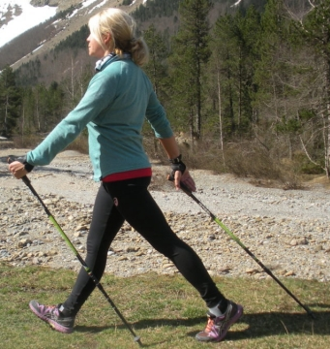 |  | 
NORDIC WALKING

Date: Thursday 17 July 2025
Time: 2pm (arrival at 1.50pm)
Venue: Southwell Park War Memorial Ground, NG25 0JP
Price: £8 per person
Closing Date: Tuesday 24 June 2025
Online Booking: N/A

Nordic Walking is a versatile and fun variation of walking which involves the use of specially designed poles. It enhances walking technique using poles to work your upper body as well as your legs and gives a highly effective all over workout that doesn’t feel like one! Nordic Walking can release tension in your neck and shoulders; improve your posture and gait; strengthen your back and abdominal muscles; and reduce the impact on your joints.

Please complete the application form below and send to Notts Fed of WIs, Trent Bridge House, Beastmarket Hill, Newark, Notts, NG24 1BN or scan it to admin@nottswi.org.uk and either send a cheque made payable to Notts Fed of WIs (2 signatures on WI cheques please) or a BACS payment. All proceeds raised by this event will go into Federation funds. If, a week before the event, you have not received any tickets or notification that the event has been cancelled, please contact the office.

Nordic Walking – 17 July 2025
WI |  |  |  | Contact Name
Tel No |  |  | Email
_____ ticket(s) required at £8 per person.

Total payment of £_____. Please tick payment method (See ‘How to Book’ below for further information):
Cash or card (in person in the office)
Cheque
BACS using ref ‘SL019’ was sent on ______________

Booking and Payment Options:
By Post  (BACS payment) | Apply using this form and send it to the address above. Send payment to Virgin Money Sort Code: 05 06 22; Account No: 50342581; Account Name: Notts Fed WI Regd Charity. Ref: use reference above and state when the BACS payment was sent.
By Post  (Cheque payment) | - Apply using this form and send to the address above with your cheque.  - Confirmation will be sent by email OR insert your postal address include £1.50 p&p.
In person in the office | Use this form, attend the office, and pay by cash, cheque or card.

