CREATIVE ACTIVITIES  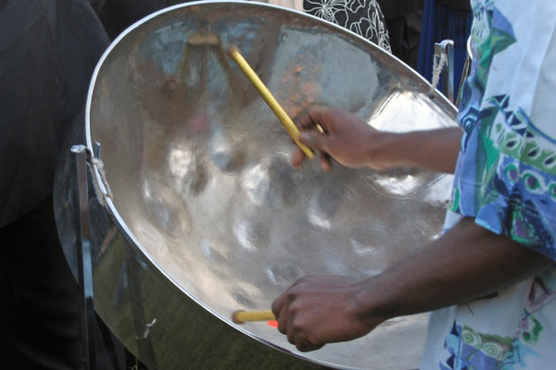 |  | 
STEELPAN DRUMMING

Date: Saturday 20 September 2025
Time: 1.30pm
Venue: Hucknall Central Methodist Church Hall
Price: £16 including tea and biscuits
Closing Date: Monday 25 August 2025

Due to a change of date, there are tickets available for this event.

This is a great opportunity to experience a hands-on musical activity using steelpan drums. The session will last around 3 hours and you will be split into two groups, each having drumming tuition and swapping periodically during the with the other group. The session is great fun so come along and learn something new.

Please complete the application form below and send to Notts Fed of WIs, Trent Bridge House, Beastmarket Hill, Newark, Notts, NG24 1BN or scan it to admin@nottswi.org.uk and either send a cheque made payable to Notts Fed of WIs (2 signatures on WI cheques please) or a BACS payment. All proceeds raised by this event will go into Federation funds. If, a week before the event, you have not received any tickets or notification that the event has been cancelled, please contact the office.

Steelpan Drumming – 20 September 2025
WI |  |  |  | Contact Name
Tel No |  |  | Email
_____ place(s) required at £16 per person.

Total payment of £_____. Please tick payment method (See ‘How to Book’ below for further information):
Cash or card (in person in the office)
Cheque
BACS using ref ‘CA018’ was sent on ______________

Booking and Payment Options:
By Post  (BACS payment) | Apply using this form and send it to the address above. Send payment to Virgin Money Sort Code: 05 06 22; Account No: 50342581; Account Name: Notts Fed WI Regd Charity. Ref: use reference above and state when the BACS payment was sent.
By Post  (Cheque payment) | - Apply using this form and send to the address above with your cheque.  - Confirmation will be sent by email OR insert your postal address include £1.50 p&p.
In person in the office | Use this form, attend the office, and pay by cash, cheque or card.

