CREATIVE ACTIVITIES  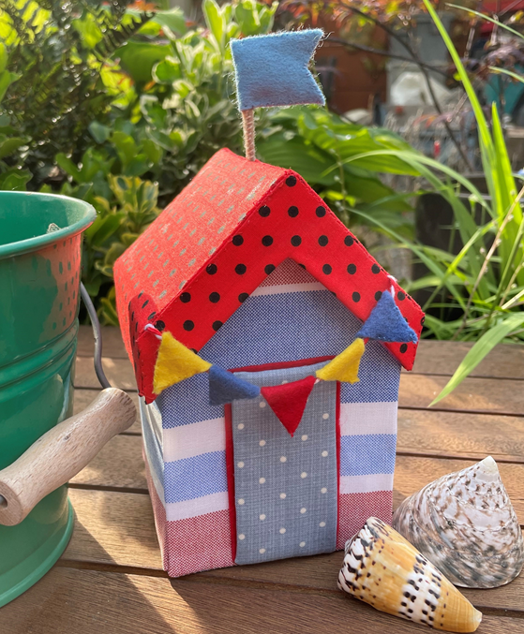 |  | 
Beach Hut Etui
with pin-cushion

Date: Saturday 21 September 2024
Time: 9.30 for 10am start – 3pm
Venue: Trent Bridge House, Beastmarket Hill, Newark, Notts, NG24 1BN
Price: £25 to include all materials
Closing Date: Monday 2 September 2024

Make a fabulous beach hut etui to hold your sewing notions as well as a pin-cushion and thimble case. Dimensions for the project at height 6”, base 3.5” square. You will need to bring your own basic sewing kit although there is only a small amount of sewing involved in the project and everything else you need will be included in the materials pack. You will need to bring your own lunch but hot drinks will be provided.

Please complete the application form below and send to Notts Fed of WIs, Trent Bridge House, Beastmarket Hill, Newark, Notts, NG24 1BN along with a cheque made payable to Notts Fed of WIs (2 signatures on WI cheques please). All proceeds raised by this event will go into Federation funds. If, a week before the event, you have not received any tickets or notification that the event has been cancelled, please contact the office.

Beach Hut Etui – 21 September 2024
WI |  |  |  | Contact Name
Tel No |  |  | Email
Address (only if tickets are to be posted out):
I require _____ ticket(s) at £25 per person. Total payment of £_____. Please tick payment method (see below) for further information).

Cash or card (in person in the office)
Cheque
BACS using ref ‘CA016’ was sent on ______________

Booking and Payment Options:
By Post  (BACS payment) | - Apply using this form and send to the address above.  - Our Bank details are:  Virgin Money (previously Yorkshire Bank/Clydesdale Bank)  Sort Code: 05 06 22; Account No: 50342581; Account Name: Notts Fed WI Regd Charity  Ref: use reference given form and state when the BACS payment was sent.
By Post  (Cheque payment) | - Apply using this form and send to the address above, along with your cheque made payable to Notts Fed of WIs.  - Please insert your email address as tickets will be sent this way unless you complete the postal address section (please include £1 p&p).
In person in the office (cash/cheque/card) | Apply using this form, attend in person in the office, and pay cash for which a receipt will be given, by cheque or card.

