NOTTINGHAMSHIRE FEDERATION BOARD of TRUSTEES
365 access for WI members

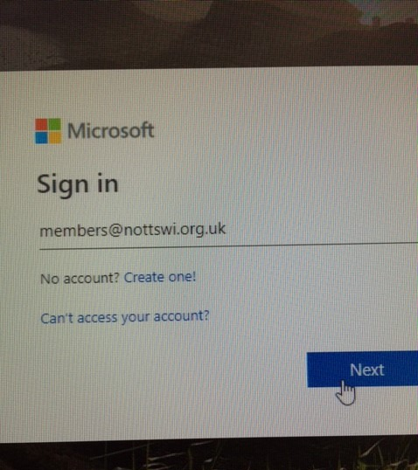 | 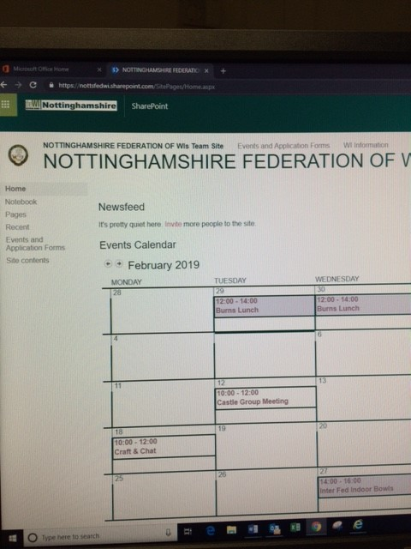

Now all our WI members can access our secure Nottinghamshire WI site. This is how:

- Search for Office.com on the internet. On the “Welcome to Office” page click sign in.

- Sign in using members@nottswi.org.uk (see pic) then press Next.

- Enter password CountyHouse1975

- You will see a page with the Apps and symbols for One Drive, Word, Excel, PowerPoint, One Note and SharePoint. Click SharePoint.

- On the “Frequent Sites” page, move to the top of the page, onto the black web address bar, and delete everything after https://nottsfedwi.sharepoint.com. Press enter.

- You can now see the Events Calendar showing forthcoming Federation events throughout the year. At the top of the page you can click on “Events and Application Forms” to see any enclosures which have been sent out. We will be adding further items to the “WI Information” section.

- When they get to the calendar page there is a star and the word follow, press this and also bookmark the page with the star in the top right corner.
- Doing this will save the page so you don't need to keep putting the password in.

We hope you will find this a useful additional reference tool.

