  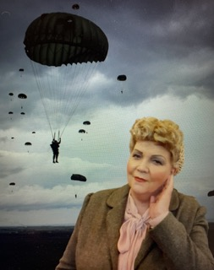  Peggy Knight | FEDERATION DAY
(including Annual Federation Meeting)

Date: Saturday 14 June 2025
Time: Workshops 10.30am-midday (doors open 9.30am),
Annual Federation Meeting: 1.15pm-3.30pm
Venue: The Minster School, Southwell, NG25 0LG
Price: see below
Closing Date: Tuesday 27 May 2025
This year we have a different format for our meeting: you can choose to attend the Federation Meeting taking place in the afternoon only or attend a workshop in the morning followed by the Federation Meeting.
Workshop Options – all at £10 per person (delegates must pay to attend a workshop)
Doors open at 9.30am. Workshops run from 10.30am to midday (approx)
 | A: Kurling  Have a go at kurling with help from the Sport & Leisure Team and take part in a competition. |  | 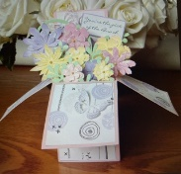 | D: papercraft  Make a pop-up box card with Anne. All materials provided.
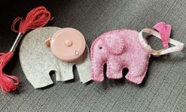 | B: Needlecraft  Make an elephant shaped tape-measure cover. All materials provided. |  | 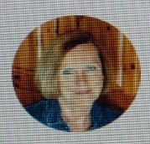 | E: Jill Berry (author)  Author of 3 novels giving a talk on writing fiction.
 | C: Wellbeing  An insight into Meditation and Mindfulness with Stephen Langford. |  | Tea/coffee available from 9.30am.  Please bring your own lunch.
The Annual Federation Meeting will begin at 1.15pm with doors opening at midday. Following WI business, historian, Lesley Smith will appear as Peggy Knight: “In 1944 a young woman, previously a typist, was parachuted into Nazi occupied France working for Special Ops. With little training and one practice parachute jump, her story of immense courage in dangerous situations is both breathtaking and remarkable”.
Free parking for this ground floor event, with Federation Team displays, Prize Draw, SNRB competition and craft stalls. There is no charge for a delegate ticket as delegates are required for voting purposes and to give a report at their WI, but if they wish to attend a workshop, that must be paid for.
Please complete the application form below, and on reverse. All proceeds raised by this event will go into Federation funds. If, a week before the event, you have not received any tickets, please contact the office.

Federation Day – 14 June 2025
WI: |  |  |  | Contact Name:
Tel No: |  |  | Email:
Please complete the information below:

____ Delegate attending AFM only or Unable to attend – please send our apologies
____ Delegate attending WORKSHOP @ £10 and AFM (complete workshop choice on reverse of form).
____ Members attending AFM only: @ £10 each. Check in from midday.
____ Members attending WORKSHOP & AFM @ £20 each (complete workshop choice on reverse of form).

Total payment of £___________. Please tick payment method.

Cash or card (in person in the office) Cheque BACS using ref ‘BT030’ sent on________
Please advise any disability requirements to admin@nottswi.org.uk
See overleaf for booking and payment options, and workshop choice form.

(BACS payment) | Send payment to Virgin Money Sort Code: 05 06 22; Account No: 50342581; Account Name: Notts Fed WI Reg’d Charity. Please use the reference above and stating when the BACS payment was sent & send application form to the address below or to admin@nottswi.org.uk
By Post  (Cheque payment) | - Apply using this form and send to Notts Fed of WIs, Trent Bridge House, Beastmarket Hill, Newark, Notts, NG24 1BN with a cheque made payable to Notts Fed of WIs (2 signatures on WI cheques please).  - Confirmation will be sent by email OR insert your postal address and include £1 p&p.
In person in the office | Use this form, visit the office, and pay by cash, cheque or card.

Kurling: Have a go at kurling | A
Needlecraft: make a felt elephant shaped tape-measure cover | B
Wellbeing: Meditation and Mindfulness with Stephen | C
Papercraft: create your own pop-up box card | D
Talk by author, Jill Berry | E

Name | Workshop Choice (A, B, C, D, E)

