NOTTINGHAMSHIRE FEDERATION OF WIs
SPORTS & LEISURE SUB-COMMITTEE

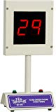 |  | 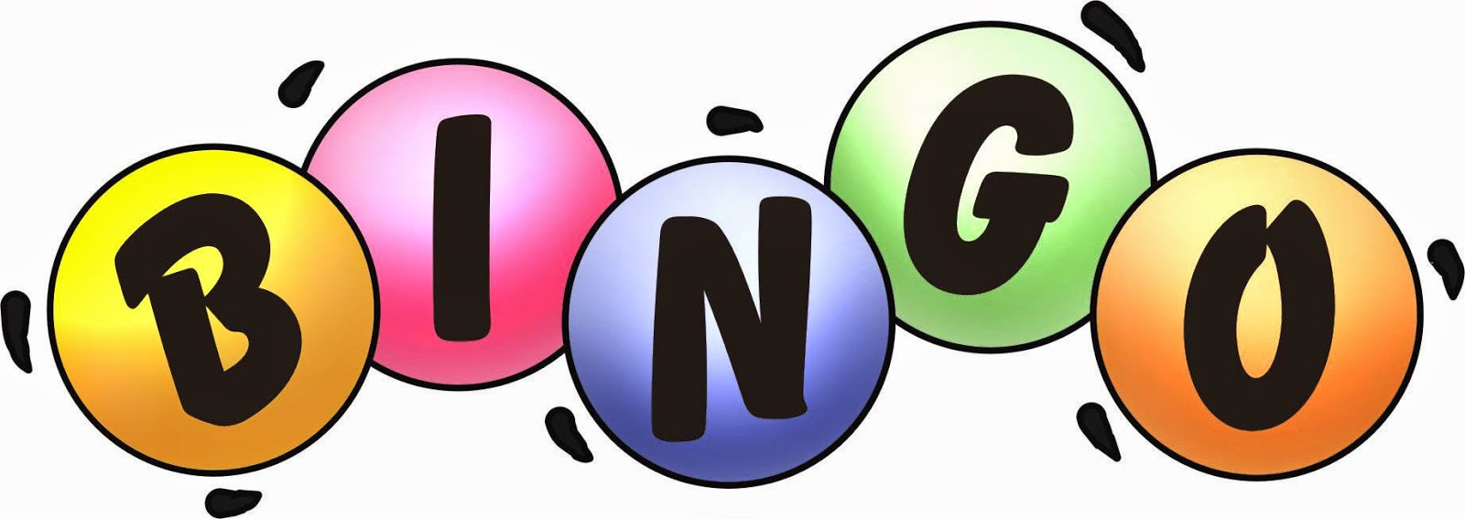  Machine for Hire
Why not hold your own Bingo evening in your WI? We have a Bingo machine which you can hire for £10 (+£40 security deposit, held until its safe return).

Please complete the form below and either email it to assistsec@nottswi.org.uk or post to Trent Bridge House, Beastmarket Hill, Newark, Notts, NG24 1BN.

Hire of Bingo Machine

WI ____________________________ Contact Name: _______________________

Address: ____________________________________________________________

____________________________________________________________________

Email: Tel No: _____________________________

Confirmation will be sent via email unless you state your postal address.

Date of Event:
Date of Collection:
Date of Return:
Cost of Hire | £10 enclosed  Please make cheques payable to Notts Fed of WIs please. Cheques will not be processed until we can confirm the machine is available.
Security Deposit | £40  Required upon collection of the Bingo machine which will handed back on its safe return.
For office use:

Cheque received £________ Confirmation sent _____________________
(email/post)

