WI SUPPORT TEAM

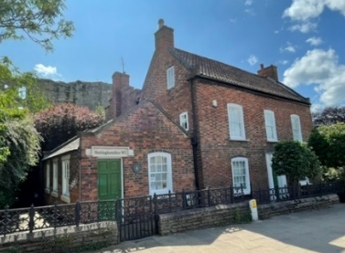
DID YOU KNOW …

YOU CAN BOOK A WI VISIT TO THE FEDERATION OFFICE?

- Do you have members who have no idea where the office is or have never visited?
- Would they like to visit and have a tour hosted by the WI Support Team?
- Find out what goes on in the office and meet the staff (if visiting on a workday).
- Enjoy refreshments in our River Room; home of committee meetings and events.
- Why not make a day of it; have lunch and a wander our historic town?
- We make no charge for your visit to the office.
Group bookings only please. Booking is essential, please complete the form below, return it to the office and we will get back in touch with you to arrange a mutually convenient date.

Book a Visit to County House

WI |  |  |  | Contact Name
Tel No |  |  | Email
No of members attending:

WI SUPPORT TEAM

DID YOU KNOW …

YOU CAN BOOK A WI VISIT TO THE FEDERATION OFFICE?

- Do you have members who have no idea where the office is or have never visited?
- Would they like to visit and have a tour hosted by the WI Support Team?
- Find out what goes on in the office and meet the staff (if visiting on a workday).
- Enjoy refreshments in our River Room; home of committee meetings and events.
- Why not make a day of it; have lunch and a wander our historic town?
- We make no charge for your visit to the office.
Group bookings only please. Booking is essential, please complete the form below, return it to the office and we will get back in touch with you to arrange a mutually convenient date.

Book a Visit to County House

WI |  |  |  | Contact Name
Tel No |  |  | Email
No of members attending:

