CREATIVE ACTIVITIES  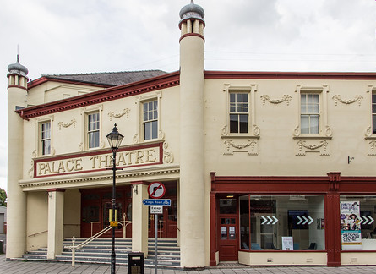 |  | 
NEWARK PALACE THEATRE TOUR

Date: Wednesday 9 April 2025
Time: 10.30am
Venue: Palace Theatre, Appletongate, Newark, NG24 1JY
Price: £15 including cake, tea/coffee
Closing Date: Tuesday 25 March 2025
Online Booking link: https://www.trybooking.com/uk/EDYV

Take a peek behind the curtain of the Palace Theatre, Newark which opened in 1920 and has subsequently had a fantastic program of entertainment including music, comedy and drama. Find out what it’s really like behind the scenes of a theatre and how they make shows come to life on stage. The tour involves a lot of stairs so please bear this in mind before booking your place.

Please complete the application form below and send to Notts Fed of WIs, Trent Bridge House, Beastmarket Hill, Newark, Notts, NG24 1BN along with a cheque made payable to Notts Fed of WIs (2 signatures on WI cheques please). All proceeds raised by this event will go into Federation funds. If, a week before the event, you have not received any tickets or notification that the event has been cancelled, please contact the office.

Theatre Tour – 9 April 2025
WI |  |  |  | Contact Name
Tel No |  |  | Email
Address (only if tickets are to be posted out):
Please book _____ place(s) at £15 per person.

Total payment of £_____. Please tick payment method (see below for further information).
Cash or card (in person in the office)
Cheque
BACS using ref ‘CA011’ was sent on ______________

Booking and Payment Options:
Online | Use the link at the top of the page to book and pay online. A transaction fee will be charged.
By Post  (BACS payment) | Apply using this form and send it to the address above. Send payment to Virgin Money Sort Code: 05 06 22; Account No: 50342581; Account Name: Notts Fed WI Regd Charity. Ref: use reference above and state when the BACS payment was sent.
By Post  (Cheque payment) | - Apply using this form and send to the address above with your cheque.  - Confirmation will be sent by email OR insert your postal address include £1 p&p.
In person in the office | Use this form, attend the office, and pay by cash, cheque or card.

