BOARD OF TRUSTEES  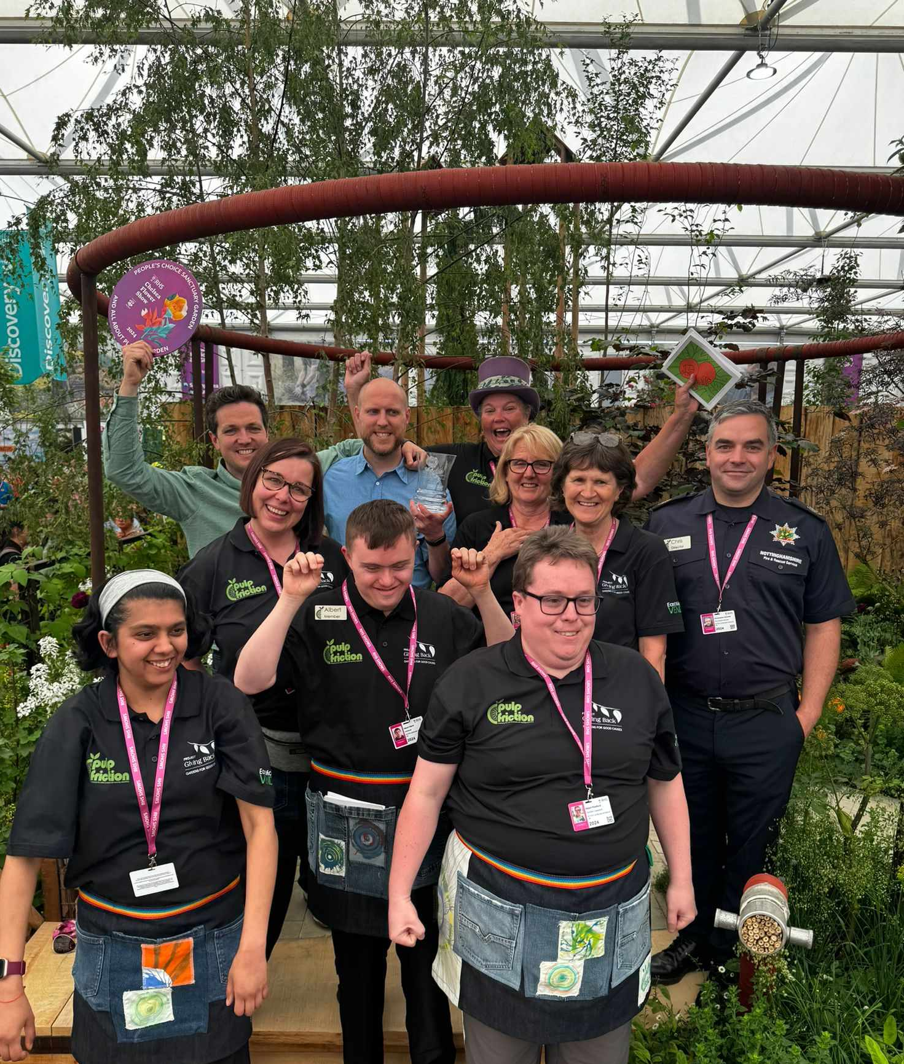 |  | 
ANNUAL FEDERATION MEETING

Date: Saturday 29 March 2025
Time: 2.30pm-4.30pm (doors open 1.15pm)
Venue: The Minster School, Southwell, NG25 0LG
Price: Early Bird £8.50, regular price £10 per ticket
(no charge for delegates)
Closing Date: Friday 14 March 2025
Booking & Payment link: https://www.trybooking.com/uk/EEGD

This year we have a different format for our meeting. Doors open to members at 1.15pm to browse various stalls and have lunch with friends (either bring your own, there is plenty of seating, or order a “lunch in a bag”). The meeting begins at 2.30pm until 4.30pm. Our speaker is Jill Carter, founder of a local charity “Pulp Friction” creating employment opportunities for the disabled, who will be telling their story and culminating in their award winning “All About Plants” Chelsea Flower Show experience.

There is ample free parking for this ground floor event, with Federation Team displays, prize draw and various craft market stalls. Refreshments will be available from 1.15pm. There is no charge for a delegate ticket as delegates are required for voting purposes and to give a report of the meeting at their WIs.
Please complete the application form below. All proceeds raised by this event will go into Federation funds. If, a week before the event, you have not received any tickets, please contact the office.
Annual Federation Meeting – 29 March 2025
WI |  |  |  | Contact Name
Tel No |  |  | Email
Address (only if tickets are to be posted out):
Please complete the information below:

- Delegate: Name: ______________________ or Unable to attend – please send our apologies
- Members wishing to attend: ______ Early Bird ticket(s) (£8.50 per person. Book before 17th February).
- Members wishing to attend: ______ Regular ticket(s) (£10 per person after 17th February).
- Disabled access: ______ space(s) required
- Lunchbox: _____ required (£8 per person payable on booking)
Please let us know if you have any dietary requirements:

Total payment of £___________. Please tick payment method.

Cash or card (in person in the office) Cheque

BACS using ref ‘BT030’ was sent on ______________

Booking and Payment Options:
Online | Use the link at the top of the page to book and pay online. A transaction fee will be charged.
(BACS payment) | Send payment to Virgin Money Sort Code: 05 06 22; Account No: 50342581; Account Name: Notts Fed WI Reg’d Charity. Please use the reference above and stating when the BACS payment was sent & send application form to the address below or to admin@nottswi.org.uk
By Post  (Cheque payment) | - Apply using this form and send to Notts Fed of WIs, Trent Bridge House, Beastmarket Hill, Newark, Notts, NG24 1BN with a cheque made payable to Notts Fed of WIs (2 signatures on WI cheques please).  - Confirmation will be sent by email OR insert your postal address and include £1 p&p.
In person in the office | Use this form, visit the office, and pay by cash, cheque or card.

