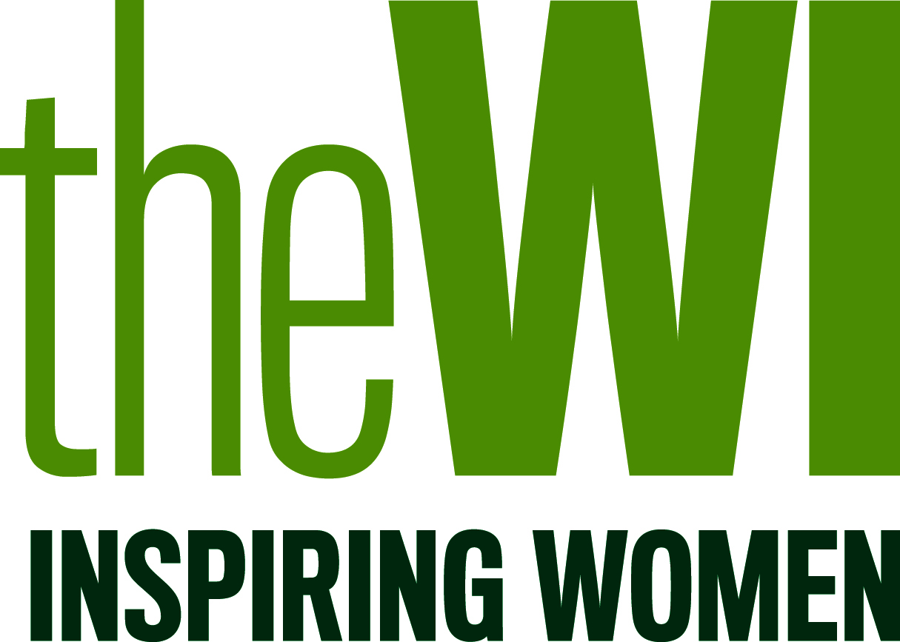
In order to Gift Aid your donation you must tick the box below:
I want to Gift Aid my donation of £XX and any donation I make in the future or have made in the past 4 years to:
Name of WI: £XX and

Federation name: £12.05 and

The National Federation of Women’s Institutes (NFWI) £13.85

I am a UK taxpayer and understand that if I pay less Income Tax and/or Capital Gains Tax than the amount of Gift Aid claimed on all my donations in that tax year it is my responsibility to pay any difference.
My Details
Title ______ First name ______________________

Surname _________________________________
Full home address ______________________________________________

_______________________________________ Postcode _____________

Signature_________________________________ Date_______________

Please notify the WI if you:
- want to cancel this declaration
- change your name or home address, or
- no longer pay sufficient tax on your income and/or capital gains.
If you pay Income Tax at the higher or additional rate and want to receive the additional tax relief due to you, you must include all your Gift Aid donations on your Self-Assessment tax return or ask HM Revenue and Customs to adjust your tax code.

Gift Aid Declaration
Boost your subscription by 25p of Gift Aid for every £1 you pay
Your membership subscription is split between your WI, your local Federation and the NFWI. The NFWI writes to your WI each year stating the portion that goes to each party and you can also view this on the WI website. Each share of your subscription qualifies as a donation for Gift Aid which is reclaimed by the charity from the tax you pay for the current tax year.
Please complete this form and give it to your WI. A copy will be forwarded to your Federation and the NFWI. Your address is needed to identify you as a current UK taxpayer.
PLEASE COMPLETE IN BLOCK CAPITALS
Data Protection: Your personal information is collected to enable your WI, Federation and the NFWI to claim Gift Aid on their shares of the WI subscription. Your information will be shared with HMRC for this purpose; https://www.gov.uk/donating-to-charity/gift-aid. Your information will be held securely by the WI, Federation and the NFWI for six years in accordance with tax and data protection laws. If you have any queries on how your data is handled, please email the NFWI at dataprotection@nfwi.org.uk
The full NFWI Privacy Policy can be found online - https://www.thewi.org.uk/privacy-policy.

