WI SUPPORT TEAM   |  | 
WI OFFICERS’ WORKSHOP

Date: Monday 6 October 2025
Time: 10am-12noon
Venue: Online via Teams
Price: Free
Closing Date: Friday 19 September 2025
Online Booking: https://www.trybooking.com/uk/FALM or use QR code below

This workshop will cover anything relating to any of the WI Officers’ roles particularly with regard to the new Constitution and what it means for your WI. Any questions you would like answered should be submitted prior to the workshop and by the closing date please.

Please complete the application form below and send to Notts Fed of WIs, Trent Bridge House, Beastmarket Hill, Newark, Notts, NG24 1BN along with a cheque made payable to Notts Fed of WIs (2 signatures on WI cheques please). All proceeds raised by this event will go into Federation funds. If, a week before the event, you have not received any tickets or notification that the event has been cancelled, please contact the office.

WI Officers’ Workshop – 6 October 2025
WI |  |  |  | Contact Name
Tel No |  |  | Email
I require _____ place(s) for this FREE online event.  The link for this online event will be sent to you via email on or around 22 September 2025. |  |  |  |  |  | Book using the QR code below:  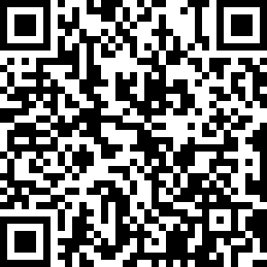

Booking and Payment Options:
Online | Use the link at the top of the page or QR code to book and pay online. A transaction fee will be charged.
By Post  (BACS payment) | Apply using this form and send it to the address above. Send payment to Virgin Money Sort Code: 05 06 22; Account No: 50342581; Account Name: Notts Fed WI Regd Charity. Ref: use reference above and state when the BACS payment was sent.
By Post  (Cheque payment) | - Apply using this form and send to the address above with your cheque.  - Confirmation will be sent by email OR insert your postal address include £1.50 p&p.
In person in the office | Use this form, attend the office, and pay by cash, cheque or card.

