SPORT & LEISURE TEAM  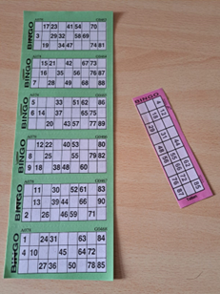 |  | 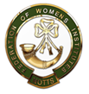
BINGO
with a Pie & Pea supper

Date: Friday 2 May 2025
Time: 7pm
Venue: Lowdham Village Hall, Main Street, Lowdham, Notts, NG14 7BD
Price: £12 (plus books bought on the night)
Closing Date: Tuesday 15 April 2025
Online Booking: https://www.trybooking.com/uk/EJBR

A great evening playing Bingo followed by a fabulous supper prepared by the Sports & Leisure team. Please inform us of any dietary requirements! We will play traditional bingo along with a selection of others. You will need to purchase bingo tickets on the night at a cost of £1.50 per book which will give you 10 opportunities to win although you can buy more than one book. The money raised from sale of the books, will form the prize money for the evening. Please bring your own glasses and drinks.

Please complete the application form below and send to Notts Fed of WIs, Trent Bridge House, Beastmarket Hill, Newark, Notts, NG24 1BN along with a cheque made payable to Notts Fed of WIs (2 signatures on WI cheques please). All proceeds raised by this event will go into Federation funds. If, a week before the event, you have not received any tickets or notification that the event has been cancelled, please contact the office.

Bingo with Pie & Pea Supper – 2 May 2025
WI |  |  |  | Contact Name
Tel No |  |  | Email
Address (only if tickets are to be posted out):

I require _____ ticket(s) required at £12 per person. Total payment of £_____. Please tick payment method (See ‘How to Book’ below for further information):
Cash or card (in person in the office)
Cheque
BACS using ref ‘SL001’ was sent on ______________

Please list any dietary requirements:

Booking and Payment Options:
Online | Use the link at the top of the page to book and pay online. A transaction fee will be charged.
By Post  (BACS payment) | Apply using this form and send it to the address above. Send payment to Virgin Money Sort Code: 05 06 22; Account No: 50342581; Account Name: Notts Fed WI Regd Charity. Ref: use reference above and state when the BACS payment was sent.
By Post  (Cheque payment) | - Apply using this form and send to the address above with your cheque.  - Confirmation will be sent by email OR insert your postal address include £1 p&p.
In person in the office | Use this form, attend the office, and pay by cash, cheque or card.

