CREATIVE ACTIVITIES  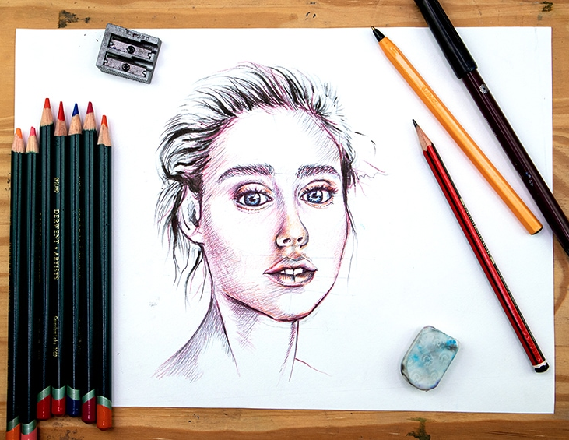 |  | 
VISOODLING

Date: 17 October 2025
Time: 9.30am-12noon
Venue: Sylvia Bell Room at Oxton Village Hall, NG25 0SA
Price: £28 per person
Closing Date: Wednesday 17 September 2025
Online Booking: https://www.trybooking.com/uk/FAKW
Or use the QR code below

What is Visoodling, you might ask! The tutor, Paula Bell, will show you how to create a simple portrait painting with watercolour pencils and the aim will be to create a gallery of your friends. This promises to be a fun morning workshop!

Please complete the application form below and send to Notts Fed of WIs, Trent Bridge House, Beastmarket Hill, Newark, Notts, NG24 1BN along with a cheque made payable to Notts Fed of WIs (2 signatures on WI cheques please). All proceeds raised by this event will go into Federation funds. If, a week before the event, you have not received any tickets or notification that the event has been cancelled, please contact the office.

Visoodling – 17 October 2025
WI |  |  |  | Contact Name
Tel No |  |  | Email
I require _____ ticket(s) at £28 per person. Total payment of £_____. Please tick payment method (see below) for further information).  Cash or card (in person in the office)  Cheque  BACS using ref ‘CA003’ was sent on _________ |  |  |  |  |  | Or use this QR code to book online:  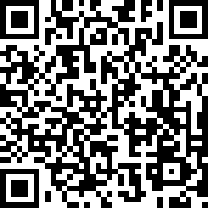

Booking and Payment Options:
Online | Use the link at the top of the page or the QR code to book/pay online. A transaction fee will be charged.
By Post  (BACS payment) | Apply using this form and send it to the address above. Send payment to Virgin Money Sort Code: 05 06 22; Account No: 50342581; Account Name: Notts Fed WI Regd Charity. Ref: use reference above and state when the BACS payment was sent.
By Post  (Cheque payment) | - Apply using this form and send to the address above with your cheque.  - Confirmation will be sent by email OR insert your postal address include £1.50 p&p.
In person in the office | Use this form, attend the office, and pay by cash, cheque or card.

