BOARD OF TRUSTEES  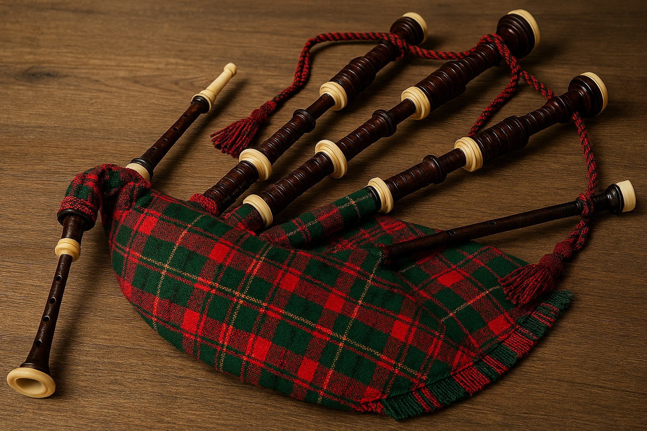 |  | 
BURNS’ LUNCH

Date: Thursday 22 January 2026
Time: 12.00 for lunch at 12.30pm
Venue: The Hostess Restaurant, Sookholme Road,
Sookholme, Mansfield NG19 8LL
Price: £32.00 including coffee
Closing Date: Monday 12 January

Come along, meet with your WI friends and enjoy a three-course traditional Scottish Burns' lunch. It wouldn't be the same without a bit of music... so a piper is coming along with his bagpipes to add to the Celtic atmosphere. The following menu choices will be available to order on the day. No need to pre-order. Vegetarian and vegan menu options will also be available. 40 people minimum required for this event.

STARTER | MAIN | PUDDING
Prawn and smoked salmon cocktail | Scotch salmon | Cranachan
Cock-a-leekie Soup | Scotch Haggis pie with neeps and tatties | Chocolate Profiteroles
chicken liver and whisky pate | Chicken with whisky and mushroom sauce | Apple Pie

Please complete the application form below and send to Notts Fed of WIs, PO Box 11460, Newark, Notts, NG24 1TY along with a cheque made payable to Notts Fed of WIs (2 signatures on WI cheques please). All proceeds raised by this event will go into Federation funds. If, a week before the event, you have not received any tickets or notification that the event has been cancelled, please contact the office.

BURNS LUNCH - Thursday 22 January 2026
WI |  |  |  | Contact Name
Email:
I require _____ ticket(s) at £32.00 per person. Total payment of £_____. Please tick payment method (see below) for further information).  Cheque  BACS using ref ‘BT025’ was sent on _________  Dietary/other requirements with name: |  |  |  |  |  | Or use this QR code to book online:  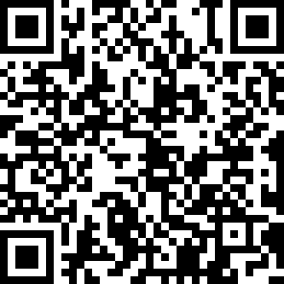
Booking and Payment Options:
By Post  (BACS payment) | - Apply using this form and send to the address above.  - Our Bank details are:  Virgin Money (previously Yorkshire Bank/Clydesdale Bank)  Sort Code: 05 06 22; Account No: 50342581; Account Name: Notts Fed WI Regd Charity  Ref: use reference given on form and state when the BACS payment was sent.
By Post  (Cheque payment) | - Apply using this form and send to the address above, along with your cheque made payable to Notts Fed of WIs.  - Please insert your email address as tickets will be confirmed by email.

