BOARD OF TRUSTEES |  | 
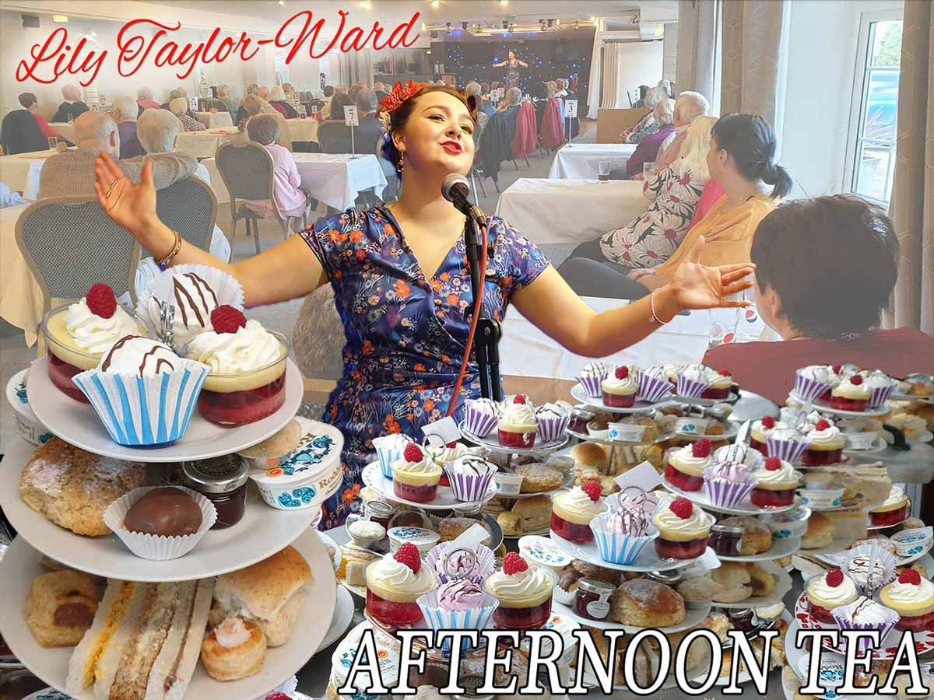 | CHRISTMAS AFTERNOON TEA  Date: Friday 29 November 2024  Time: 12.30 for 1pm (approx finish 3.30pm)  Venue: The Hostess Restaurant, Sookholme Rd,  Mansfield NG19 8LL  Price: £23.00  Closing Date: Thursday 21 November 2024 

Feeling Christmassy? Come along to enjoy a delicious selection of sandwiches, cakes and tea-time treats before listening to acclaimed classical soprano, Lily Taylor-Ward singing a selection of seasonal songs. She trained at the London College of Music and has subsequently played lead roles in numerous shows including West Side Story, Oliver! and Phantom of the Opera. Any Christmas song requests? Just let us know

Please complete the application form below and email to admin@nottswi.org.uk or send to Notts Fed of WIs, Trent Bridge House, Beastmarket Hill, Newark, Notts, NG24 1BN along with a cheque made payable to Notts Fed of WIs (2 signatures on WI cheques please). All proceeds raised by this event will go into Federation funds. NB Post will be redirected to our new address. If, a week before the event, you have not received any tickets or notification that the event has been cancelled, please contact the office.

Christmas Afternoon Tea – Friday 29 November 2024
WI |  |  |  | Contact Name
Dietary requirements: |  |  | Email:
Song request:

Address (only if tickets are to be posted out):
_____ ticket(s) required at £23 per person. Total payment of £_______. Please tick payment method, see below for further information.

Cash or card (in person in the office)
Cheque
BACS using ref “BT026” was sent on ______________

Booking and Payment Options:
By Post  (BACS payment) | - Apply using this form and send to the address above.  - Our Bank details are:  Virgin Money (previously Yorkshire Bank/Clydesdale Bank)  Sort Code: 05 06 22; Account No: 50342581; Account Name: Notts Fed WI Regd Charity  Ref: use reference given form and state when the BACS payment was sent.
By Post  (Cheque payment) | - Apply using this form and send to the address above, along with your cheque made payable to Notts Fed of WIs.  - Please insert your email address as tickets will be sent this way unless you complete the postal address section (please include £1 p&p).
In person in the office (cash/cheque/card) | Apply using this form, attend in person in the office, and pay cash for which a receipt will be given, by cheque or card.

