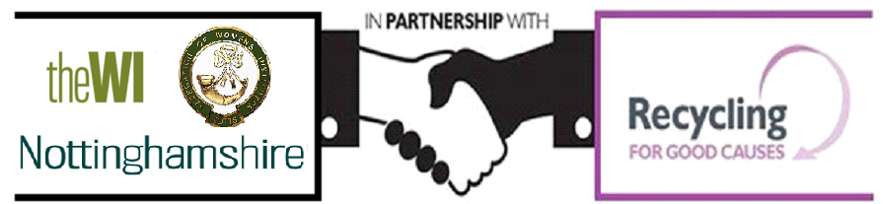

Recycling for Nottinghamshire Federation of WIs
Why not clear out your broken or unwanted jewellery and any old banknotes and donate it to raise money for the Federation? These can all be recycled at no cost to you.
We can recycle:
• Jewellery: gold, silver, costume jewellery, watches, broken or damaged items (eg odd earrings, snapped chains or items with missing stones.
• Banknotes from ANY country of any age, so any obsolete pre-euro notes are a perfect start! Please do not send coins.
Our partners at Recycling for Good Causes will reuse and recycle the jewellery and Banknotes, giving the proceeds to the Federation, saving precious raw materials at the same time.
• Stamps: All kinds of stamps are welcome, on or off paper. Simply cut or carefully tear the stamp from the envelope, being careful not to damage the stamp. Once you have a collection pop them in an envelope making sure you have the correct postage to: Nottinghamshire Federation of WIs, PO Box 16992, Sutton Coldfield, B73 9YA. Please do not send stamps using the freepost label as the costs will far outweigh the donation.
Recycling for Good Causes will arrange collections for larger quantities of stamps weighing over 10kgs. This equates to about two buckets full of stamps.
You can bring your jewellery and banknotes into the office or alternatively you can send them direct to Recycling for Good Causes in an envelope or jiffy bag (no larger than A5) using the freepost label overleaf.
For further information: info@recyclingforgoodcauses.org T: 0800 633 5323
If you have more items than will fit into an A5 sized envelope, please call 0800 633 5323 or email customerservices@recyclingforgoodcauses.org to find out more information on our polybag/sack recycling projects where you can recycle larger items. You will need to quote Nottinghamshire Federation of WIs as the good cause.

