BOARD OF TRUSTEES  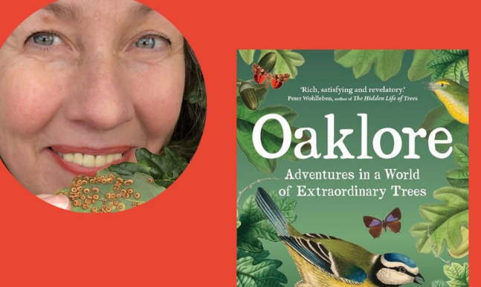 |  | 
LITERARY LUNCH

Date: Thursday 6 March 2025
Time: 12.00 for lunch at 12.30pm
Venue: Ramsdale Park Golf Club, Calverton,
Nottingham NG14 6NU
Price: £30.00 including tea/coffee
Closing Date: Wednesday 19 February

Online booking & payment link:
https://www.trybooking.com/uk/EBCK
Former journalist, Jules Acton lives and breathes trees. She lives near Sherwood Forest and works for the Woodland Trust. Her love of the oak is central to her first book, ‘Oaklore’. Oaks in the UK support 2300 other plants, animals and fungi and the book encompasses the birds, spiders, beetles and butterflies to be found on them. Jules, whose surname means ‘oak place’, can trace her love of nature back to childhood.
Enjoy a 2-course meal in the upstairs Park View restaurant, followed by tea or coffee. Please select from the options below and submit your choices and any dietary requirements on the reverse of this form. A vegan menu option will also be available.
Fillet of Salmon topped served with roast root vegetables, mashed potato and herb butter sauce, or
Roast Chicken Breast with Dauphinoise Potatoes, roast root vegetables and a red wine jus (gf), or
Spinach and mushroom filo tart with roast root veg, red wine jus and mash (vegetarian)
And for pudding: Chocolate fresh cream and fresh raspberry roulade, or
Crumble topped apple and red fruit Pie with custard.

Please complete the application form below and send to Notts Fed of WIs, Trent Bridge House, Beastmarket Hill, Newark, Notts, NG24 1BN along with a cheque made payable to Notts Fed of WIs (2 signatures on WI cheques please) All proceeds raised by this event will go into Federation funds. If, a week before the event, you have not received any tickets or notification that the event has been cancelled, please contact the office: admin@nottswi.org.uk.

LITERARY LUNCH
WI |  |  |  | Contact Name
Email |  |  |  |  | Address (only if tickets are to be posted out):
I require _____ ticket(s) at £30.00 per person. Total payment of £_____. Please tick payment method (see below) for further information.

Cash or card (in person in the office)
Cheque
BACS using ref BT028 was sent on ______________

Booking and Payment Options:
Online | Use the link at the top of the page to book and pay online. A transaction fee will be charged.
By Post  (BACS payment) | Apply using this form and send it to the address above. Send payment to Virgin Money Sort Code: 05 06 22; Account No: 50342581; Account Name: Notts Fed WI Regd Charity. Ref: use reference above and state when the BACS payment was sent.
By Post  (Cheque payment) | - Apply using this form and send to the address above with your cheque.  - Confirmation will be sent by email OR insert your postal address include £1 p&p.
In person in the office | Use this form, attend the office, and pay by cash, cheque or card.

LITERARY LUNCH
Name | Salmon | Chicken | Filo tart | Chocolate  roulade | Fruit  pie | Dietary  requirements

