BOARD OF TRUSTEES  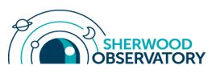 |  | 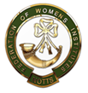
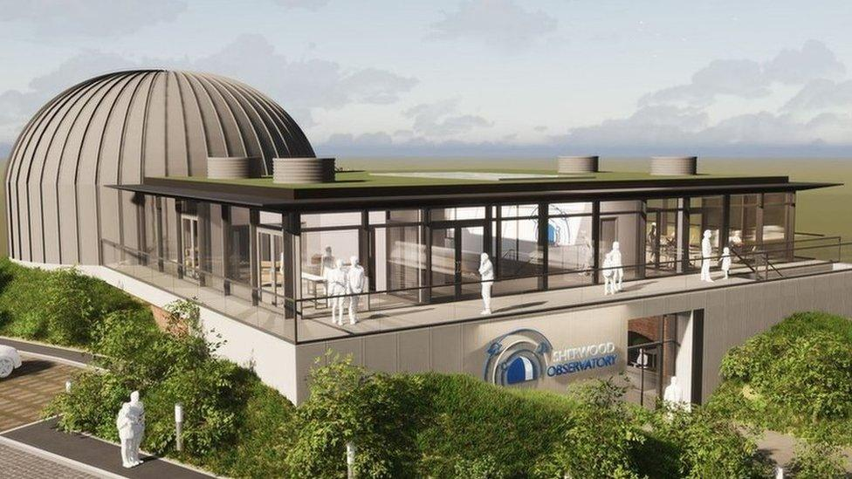 | Planetarium visit  Date: Thursday 20 February 2025  Time: 7pm – 9pm  Venue: Sherwood Observatory, Coxmoor Road,  Sutton-in-Ashfield, NG17 5LF  Price: £10.00  Closing Date: 10 February 2025  Booking & Payment Link: https://www.trybooking.com/uk/EBCF

Visit this newly built full dome planetarium to see “The Great Solar System Adventure” show, followed by a presenter-led topic entitled “What’s in the night sky at the moment”. There will also be the opportunity to visit the exhibition or telescope. Tea/coffee & biscuits included.

Please complete the application form below and send to Notts Fed of WIs, Trent Bridge House, Beastmarket Hill, Newark, Notts, NG24 1BN along with a cheque made payable to Notts Fed of WIs (2 signatures on WI cheques please). All proceeds raised by this event will go into Federation funds. If, a week before the event, you have not received any tickets or notification that the event has been cancelled, please contact the office.

Planetarium Visit – 20 February 2025
WI |  | Contact Name
Email:

I require _____ ticket(s) at £10.00 per person. Total payment of £_____. Please tick payment method (see below) for further information).

Cash or card (in person in the office)
Cheque
BACS using ref ‘BT039’ was sent on ______________

Booking and Payment Options:
Online by card | Use the link at the top of the page to book and pay online, a transaction fee will be charged.
By Post  (BACS payment) | Apply using this form and send it to the address above. Send payment to Virgin Money Sort Code: 05 06 22; Account No: 50342581; Account Name: Notts Fed WI Regd Charity. Ref: use reference above and state when the BACS payment was sent.
By Post  (Cheque payment) | - Apply using this form and send to the address above with your cheque.  - Confirmation will be sent by email OR insert your postal address include £1 p&p.
In person in the office | Use this form, attend the office, and pay by cash, cheque or card.

